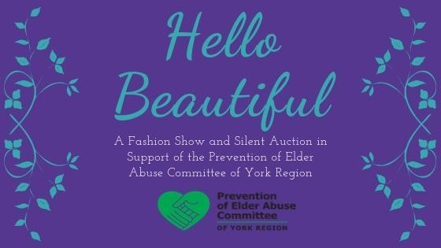

SPONSORSHIP AGREEMENT

I/we agree to sponsor the PEACYR Hello Beautiful Fashion Show and Silent Auction to be held on September 28, 2022 at the following level:

(Please check level desired)

- Our Event Partners $ 2500.00
- ½ Page Catalogue Ad $ 300.00
- ¼ Page Catalogue Ad $ 150.00
- Vendor Table $ 100.00
- Outfit a Model $ 200.00
- Silent Auction Item (Description & Value) ________________________________
- Additional Tickets $25 (Quantity) _____

Benefits:

BENEFITS | Our Event Partners  $2500 | Ad Level  $300 | Ad Level  $150 | Vendor Table  $100 | Outfit A Model  $200 | Silent Auction Item
Complimentary Tickets to Event | 5 | 3 | 1 | 1 | 2 | 0
Color Catalogue | Full Page | ½ Page | ¼ Page | Listed | Logo | Listed
Other | Vendor Table |  |  |  | Announced on Runway

Name of Company or Organization:

Address:

City: Postal Code:

Daytime Phone: E-mail: _

Name of Contact Person:

For questions please contact: Olivia Spratt (705) 896-7798

Scan and email Sponsorship Agreement and ADS (pdf format) to: peacyr1@gmail.com

Mail cheques to: Attention: Anna Malfara 291 Davis Dr. Unit 8 Newmarket, Ontario L3Y 2N6
Please make cheques payable to The Prevention of Elder Abuse Committee of York Region Thank you for your support in helping to make a difference in the lives of older adults

